Report

By Haiqin Huang(z5295162)

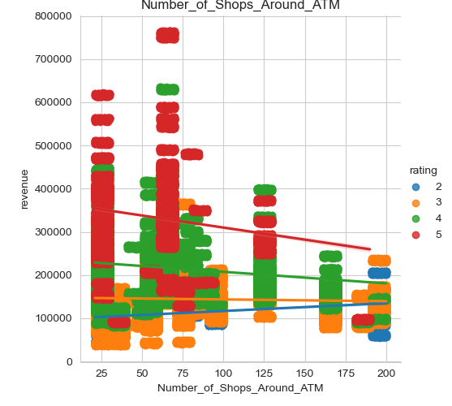Revenue and rating are two important indexes to assess banks. Therefore, I mainly use rating, revenue, and another feature to observe other features’ distribution on this chart. When revenue reaching 5,000,000 and rating reaching 4, this attribute can be recommended.

**Number_of_Shops_around_ATM:** recommend new bank set in place where shops around are about 20-30 or 60-70.

Because high revenue and high rating banks are mainly distributed in these two areas.

**ATM_Zone:**

Prefer RL, FV can also be considered.

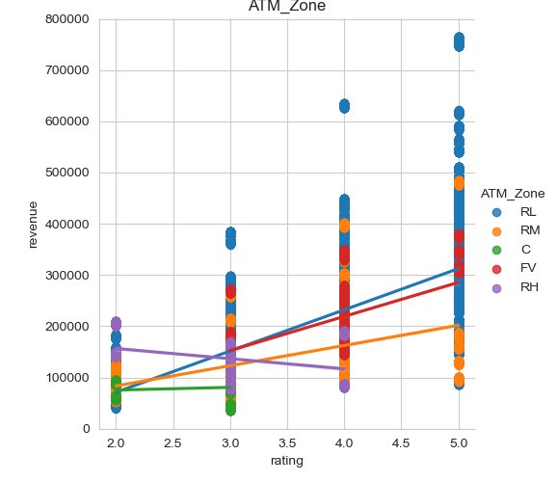Because high revenue and high rating area is mainly RL, but RL also has low assessment in other area. FV has a similar linear regression to RL, and more stable, therefore, FV can be a choice.

**No_of_Other_ATMs_in_1_KM_radius:**

Prefer 50-100.

Because almost all data in this area, this feature may have less importance.

**Estimated_Number_of_Houses_in_1_KM_Radius:**

Prefer: 10,000-20,000

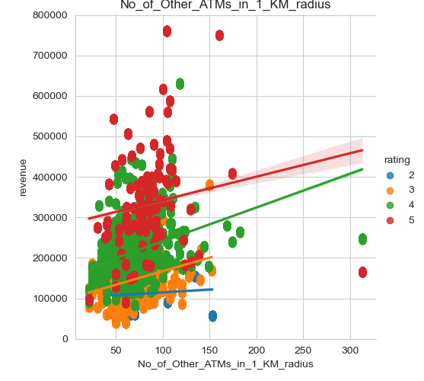Because almost all data in this area, this feature may have less importance.

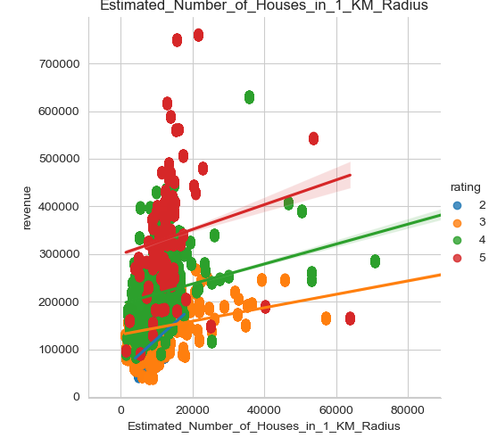

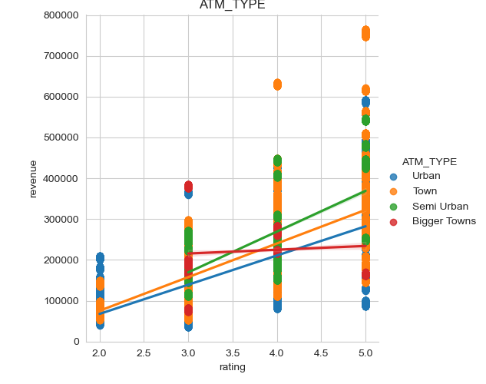**ATM_TYPE:**

Prefer: Semi Urban

Semi Urban has a better linear regression in chart.

**ATM_Location_TYPE:**

Prefer: Passbook printing and withdraw

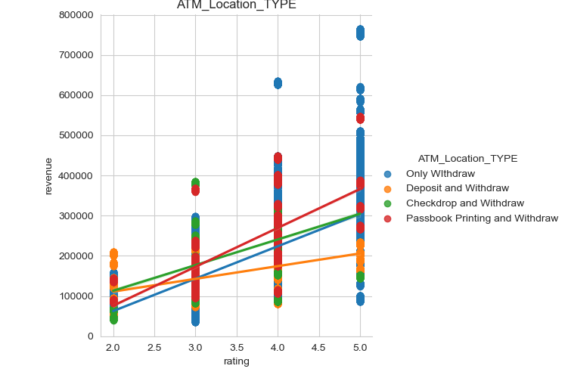Passbook printing and withdraw has better linear regression in chart.

**ATM_Attached_to:**

Prefer: Petrol Bunk or building

high revenue and high rating area is mainly Petrol Bunk or building. Though house has better line, it has less sample in high revenue and high rating area.

**ATM_Placement and ATM_Looks:**  both of them has a value take up more than 90%. Therefore, these two has less influence on revenue or rating.

**Summary: Number_of_Shops_around_ATM:**

20-30 or 60-70

**ATM_Zone:**

RL or FV.

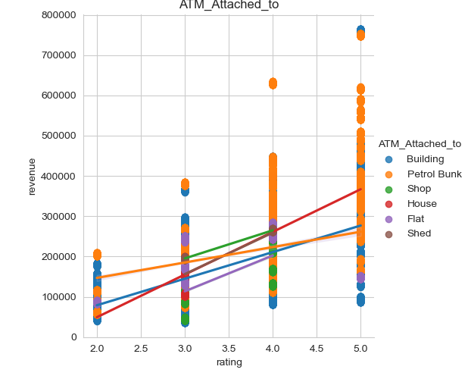**No_of_Other_ATMs_in_1_KM_radius:**

50-100.

**Estimated_Number_of_Houses_in_1_KM_Radius:**

10,000-20,000

**ATM_TYPE:**

Semi Urban

**ATM_Location_TYPE:**

Passbook printing and withdraw

**ATM_Attached_to:**

Petrol Bunk or building